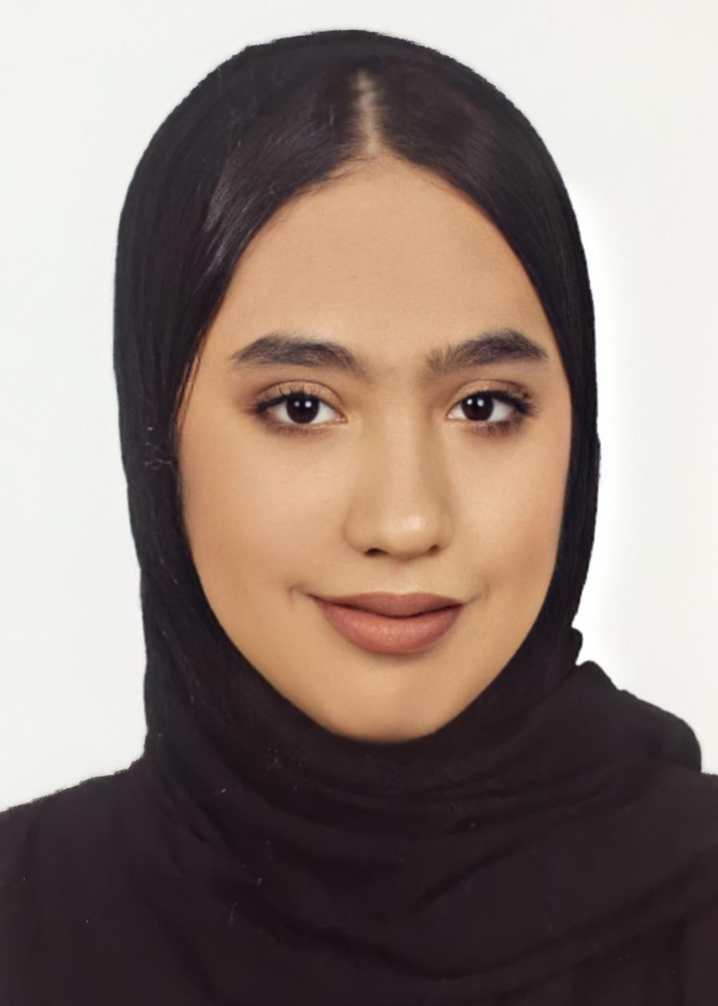

AYSHA  BURSHAID  CONTACT  Address:  Alhajiyat, Riffa ,Block 939 , Road 3933 , House 1555  Phone:  +973 3999 5928  Email:  Aishaburshaid11@gmail.com.  LANGUAGES  Arabic  English  South Korean |  | SUMMARY  Strongly focused on the ability to complete tasks accurately in a fast-paced environment with conflicting deadlines.  Driven to achieve the best results for customers.  Dedicated and customer-focused customer service with a successful background in leading high performing teams to meet or exceed objectives. A tactical and inspiring team builder with experience in training, team development, and delivering excellence.  EDUCATION  Al Maa’rifa Secondary Girls SC.  Graduated in Commercial.  ADDITIONAL SKILLS  - Active listening  - Adaptability  - Attentiveness  - Conflict resolution  - Creativity  - Decision-making  - Dependability  - Effective communication  - Empathy  - Friendliness  - Knowledge of your product or service  - Open-mindedness  - Patience  - Quick thinking  - Reading physical and emotional cues  - Responsiveness  - Timeliness

